Taibah University
Department of Computer Science - YANBU

Prepared by:
Dr. Yaser Khamayseh
Final Project Report Guide

The final project report (REPORT) is one of the required deliverables submitted towards the end of the semester (the first semester of the project). This report is the main reference to the work done by students

In this document we will guide you to deliver your report as expected in terms of structure and formats.

- Structure of REPORT
The written material mainly consists of four sections listed in order of appearance in the report: front pages; chapters, references; and appendences. The following subsequent sections briefly describe the structure and contents of each of them.

  - Front pages: These are the first few pages before the body of the report. Every report must start with a set of the first pages. These pages are listed below in the order of their appearance:
    - The title page: It contains the following information (see the template):
      - The title of the senior project
      - Fixed text varies CS and CSE students.
      - Group members’ details (name and ID) alphabetically ordered.
      - Semester and year of submission.
    - Dedication page: contains your own statements of dedications.
    - Declaration page: contain a fixed text followed by students’ names and signature and ended with the date of signing the declaration.
    - Acknowledgements: acknowledging information, assistance, etc. received during the project time.
    - Abstract page: contains the abstract of the REPORT which is a key component because it allows readers to quickly decide whether or not the report is relevant to them. The abstract is a stand-alone document, meaning that it should be thought of as being independent from the report. In other words, the readers of your abstract may not read the report; it also means that the readers of the report may not have read the abstract. The abstract should also contain all key elements of the report.
    - Table of contents: showing indexed formats of the contents of the REPORT and their respective page numbers except for the title page.
    - List of tables: listing contains the numbers and titles of tables appearing in the REPORT and their respective page numbers.
    - List of figures: listing the numbers and titles of figures appearing in the REPORT and their respective page numbers.
    - List of abbreviations: contains the abbreviations appearing in the REPORT and their respective explanations.

  - Chapters: The chapters’ naming and material enclosed are usually left to the students’ and advisory committee to decide on and are highly dependent on the nature of the project and its major goal, objectives, activities, and emphasis. However the CS REPORT must include the following chapters.
CHAPTER 1: INTRODUCTION. The sections of this chapter include:
- Project domain
- Motivation
- Problem definition
- Objective
- Methodology used (e.g. SDLC)
- Related work

CHAPTER 2: PLANNING. The sections of this chapter include:
- Project Organization
- Scope, Constraints, and Assumptions
- Feasibility
  - Technical
  - Operational
  - Timing
  - Economical
- Risks
- Project scheduling
  - Gant Chart
  - Estimation scheduling for the project

CHAPTER 3: ANALYSIS and DESIGN. The sections of this chapter include:
- Techniques used to collect requirements
- Required Hardware and Infrastructure Devices
- System Requirements
- Functional requirements
- Non Functional Requirements
- Process modeling (whichever applicable)
  - Data Flow Diagram (DFD)
  - Use Cases
- Logic Modeling (whichever applicable)
  - Structure English
  - Decision table
  - Decision tree
  - STD
- Data Model (if applicable)
  - The ER Diagram of the Database
  - The Relation of the Database

CHAPTER 4: DESIGN. The sections of this chapter include:
- Conceptual Design
- System Components

In this section, you present the main components and subcomponents of the systems and identify the relationship between these components using diagrams. Later on, you provide a detailed description of each component.

For example:
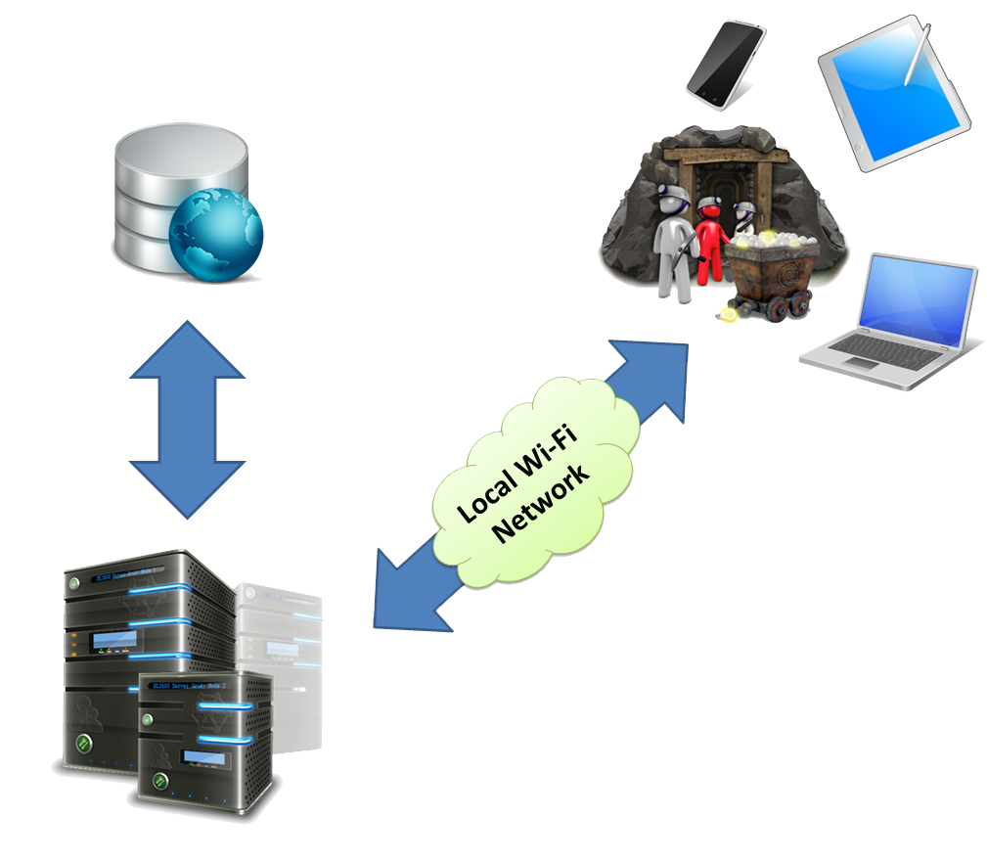
Figure 2-1 Conceptual design

The overall system is based on a central server running the main software, local database and client applications connected to the central server by an internal wireless network. Client applications are represented with mobile and web interfaces.
The system is built out of several components which interact among each other.

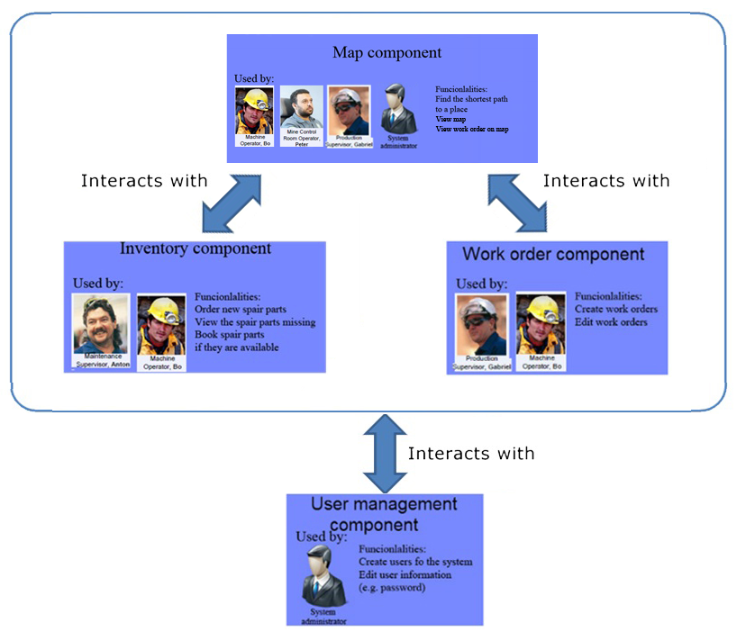
Figure 2-2 System components

- Architecture Design
In the AD phase, the software requirements are transformed into definitions of software components and their interfaces, to establish the framework of the software.
Example:
The system architecture is based on three tiers along with a database.

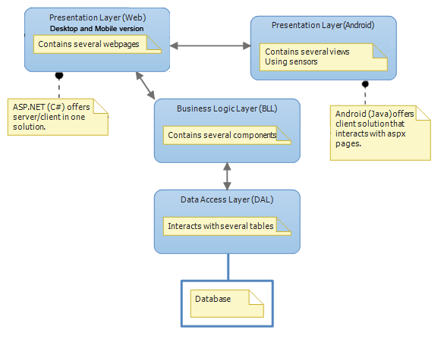
Figure 2-3 System architecture

The data access layer offers an interface between the database and the business logic. The business logic layer contains the functionalities of the central system. The presentation layer contains the client applications which provide the user interface for the system.

- Interface Design
- Forms
- Reports (if applicable)

Attached is a brief description of some of the principles that you may use in your design.

- Tools and Technologies used.

CHAPTER 5: IMPLEMENTATION. The sections of this chapter include:
  - Coding
  - Installation
  - Snapshots of the interface

CHAPTER 6: TESTING. The sections of this chapter include:
- Testing methodologies used

CHAPTER 7: CONCLUSIONS AND FUTURE WORK
- References: The citation is a short code (within the body of the report) which identifies an idea or fact the writer has borrowed from elsewhere. The list of references provides a complete and detailed list (at the end of the report) of all the sources the writer used. References list appears immediately after the body of the report. Listing of references should follow one adopted formal referencing style (IEEE referencing style is adopted). (CS-PI(h)1-B)

- Appendices (if exists)
Format of REPORT
- Paper size: A4, width 21 cm, height 29.7, header 1.27, and footer 1.7.
- Layout and margins: Portrait layout with top, bottom and right margins of 2.5 cm, left 3.5 cm and gutter 0 cm.
- Numbering system: The Arabic numbering system is used for chapter, section, subsection, table, figure, and page numbering. The font of the final report is normal 12 points single-spacing Times New Roman except for the cases explicitly stated in this document. Paragraphs are followed by one 12 points spacing line.
- Tables and figures: Every table/figure has a number and a title.
Table's caption appears on the top leftmost corner of the table with the format:
Table chapterNumber.tableNumber: Table Title.
Figure's caption appears on the bottom leftmost corner of the table with the format:
Figure chapterNumber.figureNumber: Figure Title.
Tables and figures have independent sequential numbering within each chapter. The title has Tile case format ended with a dot. The tables and figures themselves are centered in the page. Leave one 12 points line spacing before and after each table/figure. The text in the table/figure should not be less than 8 points. Page orientation can be adjusted to fit in tables/figures provided no other information on such pages.
- Chapter's numbering and headings: Every chapter has a number and a title. Numbers are sequential starting at 1. All caps format is used with centered 14 points bold font. The chapter's title line is preceded and followed by One 14 points line spacing.
CHAPTER Number

TITLE

- Chapter's body: the chapter starts with a motivation paragraph followed by the first section of the chapter and the subsequent sections. Sections headings are left aligned on a separate line numbered as bold ChapterNumber.sectionNumber followed by bold section title with only first letter capital.
ChapterNumber.sectionNumber Section Title

Subsections have the same formats with added subsection number and the title of the subsection is italic bold. Allowed depth of sections is only two. Use bullets instead of sub-sections for extra depth.

- Page numbering: Pages from the Dedication page up to the Abbreviations page are numbered in Roman (i, ii,..), positioned bottom right corner. While pages of the chapters and references are numbered in Arabic (1,2,..), positioned bottom right corner. Appendices are numbered using the appendix letter followed by Arabic numbering (A1, A2,..) positioned bottom right corner.

- REPORT cover page and first pages: Please see REPORT template.

- References format: IEEE style encloses citation numbers within the text of a report in square brackets [1]. Each citation number in the reference list is also enclosed in square brackets. A complete guide to IEEE reference style can be found on IEEE website.

- Other issues
- The report body (chapters and references) material should not exceed 50 pages in total.
- Do not include the coding of the system in the body of the report, although segments are allowed. The appropriate place for the code is to appear in the appendix and preferably on CD accompanying the report.
- Submit three copies of the report the department office at least two weeks prior to the presentation date.
- Include a CD to accompany the report with the following material saved on it:
  - The report
  - The system source code
  - The system automated deployment if done.

TITLE OF YOUR REPORT

Final Project Report Submitted to
The Department of Computer Science
Faculty of Computer Science and Engineering
University of Taibah - Yanbu

In Partial Fulfillment of the Requirements for the Degree of
BSc. in

Computer Science

By

Full names of the student (Student's ID No)
Full names of the student (Student's ID No)
Full names of the student (Student's ID No)
Full names of the student (Student's ID No)

Fall/Spring/Summer year
dedicationS
Insert your dedication text here.
Declaration

This report has not been submitted for any other degree at this or any other University. It is solely the work of us except where cited in the text or the Acknowledgements page. It describes work carried out by us for the project described in the submitted senior Project Proposal which in available in the appendices of this report. We are aware of the penalties for plagiarism fabrications and unacknowledged syndication and declare that this report is free of these.

Student’s name signature
Student’s name signature
Student’s name signature
Student’s name signature

Signed on ……………........... Date.................
ACKNOWLEDGEMENTS
All assistance, information, etc received from other people (e.g. industrial mentors, Supervisor or other academic staff, research or support staff, other students and etc) during the Project must be listed here.
ABSTRACT
Type in your abstract here, using single spaced text. Indent paragraphs with one tab space; do not insert a blank line between paragraphs.

TABLE OF CONTENTS
PAGE
DEDICATIONS #
DECLARATIONS #
ACKNOWLEDGEMENTS #
ABSTRACT #
LIST OF TABLES #
LIST OF FIGURES #
ABBREVIATIONS #

CHAPTER
1.0 INTRODUCTION #
1.1 Title of Section One #
1.1.1 First Subsection of Section One #
1.1.1.1 Maximum Level of Subsections #
1.1.1.2 Must Have At Least Two subsection #
1.1.2 Must Have At Least Two Sections #
1.2 Must Have At Least Two Sections #

2.0 FEASIBILITY STUDY AND REVIEW OF RELATED LITERATURE #

REFERENCES #
APPENDICES #
APPENDIX A: Title of Appendix A #
APPENDIX B: Title of Appendix B #

LIST OF TABLES
TABLE PAGE
1.1 Title of The First Table in Chapter 1 #
1.2 Title of The Second Table in Chapter 1 #
1.3 Title of The Third Table in Chapter 1 #
2.1 Title of The First Table in Chapter 2 #
2.2 Title of The Second Table in Chapter 2 #

LIST OF FIGURES
FIGURE PAGE
1.1 Title of The First Figure in Chapter 1 #
1.2 Title of The Second Figure in Chapter 1 #
1.3 Title of The Third Figure in Chapter 1 #
2.1 Title of The First Figure in Chapter 2 #
2.2 Title of The Second Figure in Chapter 2 #

CHAPTER 1
introduction
Every chapter starts with an introductory paragraph followed by its sections and subsections (this is a rule for every chapter in the report).

References
Follow this style of referencing using single spacing for each entry and using normal line spacing between entries.

- D. Jones, Technical Writing Style, Toronto: Allyn and Bacon, 1998.

- T. Land, “Web extension to American Psychological Association style (WEAPAS), “[Online document], 1996 Mar 31(Rev 1.2.4), [cited 1996 Sept 14], Available HTTP:http://www.nyu.edu/pages.psycology/WEAPAS.

APPENDICES

appendix a
Title

